https://docs.fortinet.com/document/fortiauthenticator/5.5.0/cookbook/16973/configuring-the-certificates
https://www.historiantech.com/how-to-set-up-a-byod-guest-portal-with-fortiauthenticator-fortigate-and-fortiap-part-1/
https://www.historiantech.com/how-to-set-up-a-byod-guest-portal-with-fortiauthenticator-fortigate-and-fortiap-part-2/
https://www.historiantech.com/how-to-set-up-a-byod-guest-portal-with-fortiauthenticator-fortigate-and-fortiap-part-3/

https://slideplayer.com/slide/6270088/
https://www.slideserve.com/hafwen/msi-packaging-for-altiris-managed-schools
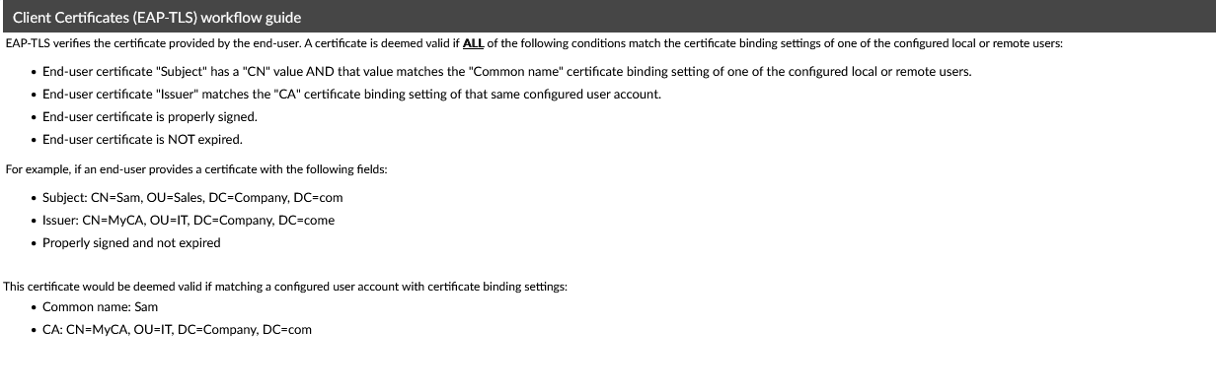

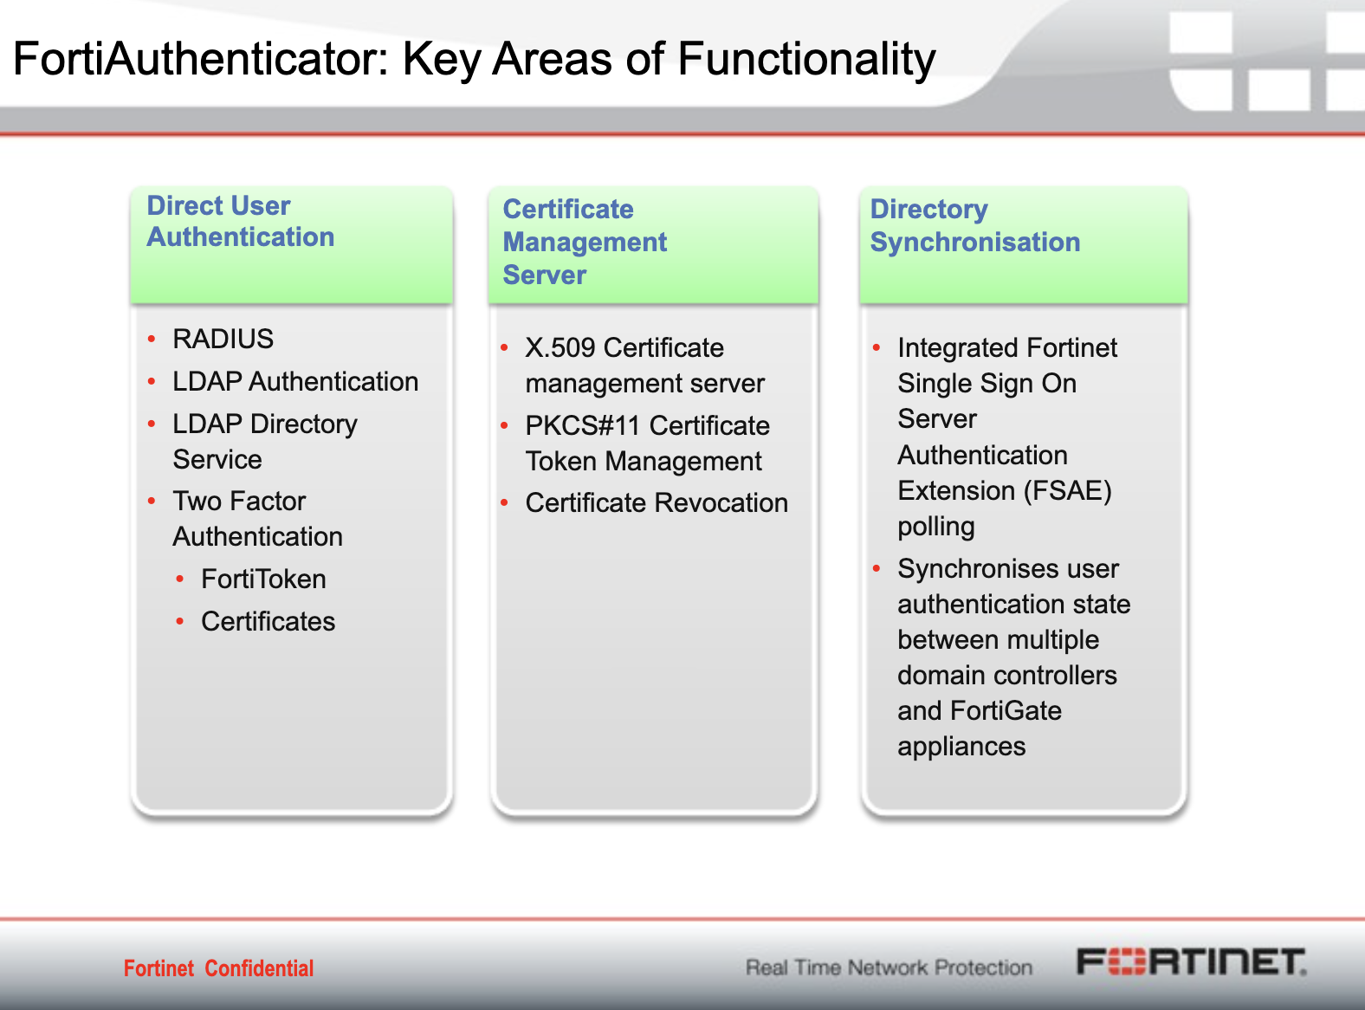

EAP protocol support different types of authentication methods. Some methods like EAP-MSCHAPv2 is very basic with MSCHAPv2 as the authentication method. This however is not very secure since the NTLM hashed password can be decrypted using brute force attacks. EAP also supports tunneled authentication methods where the credentials are exchanged inside a TLS tunnel.
First a TLS tunnel is setup between client and AAA server. Then credentials are exchanged inside the secure tunnel where its is safe from eavesdroppers. Different tunneled EAP methods are EAP-TTLS, EAP-PEAP, EAP-TLS, TEAP. In your example you have MSCHAPv2 as inner authentication method with EAP-TTLS. Here, first a TLS tunnel is formed and MSCHAPv2 authentication happens inside the tunnel. EAP lets you choose different combinations of outer and inner methods. Other examples are EAP-TTLS with PAP as inner method or EAP-PEAP with MSCHAPv2 as inner method.
Remember that EAP is an authentication framework and does not specify a specific authentication method. For that reason, multiple EAP types are used.

On EAP-TLS you are right, both sides require a certificate. With a client-side certificate, a compromised password is not enough to break into EAP-TLS enabled systems because the intruder still needs to have the client-side certificate.
On EAP-TTLS, you are right again. After the server is securely authenticated to the client via its CA certificate and optionally the client to the server, the server can then use the established secure connection ("tunnel") to authenticate the client.
PEAP is an encapsulation, is not a method, but you are almost right again. PEAP is similar in design to EAP-TTLS, requiring only a server-side PKI certificate to create a secure TLS tunnel to protect user authentication, and uses server-side public key certificates to authenticate the server. It then creates an encrypted TLS tunnel between the client and the authentication server.
The difference is: PEAP is a SSL wrapper around EAP carrying EAP. TTLS is a SSL wrapper around diameter TLVs (Type Length Values) carrying RADIUS authentication attributes.

When the RADIUS server forwards the challenge and response to the Active Directory server for authentication in an EAP-MSCHAPv2 (Extensible Authentication Protocol with Microsoft Challenge Handshake Authentication Protocol version 2) scenario, the Active Directory server performs the following steps to determine the supplicant's credentials:

1. Verification of Challenge and Response: The Active Directory server receives the challenge and response from the RADIUS server. It checks the challenge and response to verify their authenticity.

2. Challenge Authentication: The challenge provided in the authentication process is used to ensure that both the supplicant and the authentication source (in this case, the Active Directory server) are using the same secret or password. The challenge is used as a proof of knowledge of the shared secret.

3. Hashing and Comparison: The Active Directory server uses the challenge and the supplicant's response, along with the stored credentials, to perform a series of cryptographic operations. It hashes the challenge and the stored password to create a hash, and then it compares this hash with the hash of the supplicant's response. If the two hashes match, it signifies that the supplicant has successfully responded to the challenge, demonstrating knowledge of the correct password.

4. Authentication Decision: If the hashes match, the Active Directory server authenticates the supplicant. It sends an acknowledgment to the RADIUS server, which, in turn, grants the supplicant access to the network or the requested resources.

It's important to note that the actual passwords or clear text credentials are not transmitted or shared during this process. Instead, cryptographic operations are used to verify that the supplicant knows the correct password without revealing the password itself. This provides a level of security and protection against eavesdropping.

The challenge and response mechanism in EAP-MSCHAPv2 ensures that only authorized users who possess the correct password can successfully complete the authentication process.

The structure of a challenge-response packet in the context of EAP-MSCHAPv2 (Extensible Authentication Protocol with Microsoft Challenge Handshake Authentication Protocol version 2) can be quite complex, as it involves multiple steps and fields. However, I'll provide a simplified overview of what a challenge-response packet might look like to give you a general idea:

1. **Challenge Packet:** A challenge packet contains the following components:

- **Challenge:** A random value generated by the authentication server (in this case, the Active Directory server) and sent to the supplicant. This challenge is typically a random number or string. For example, "Challenge: 1234567890ABCDEF."

2. **Response Packet:** The response packet includes the following elements:

- **Username:** The username of the supplicant, which is often included in the response packet.
- **Challenge:** The challenge received from the authentication server.
- **NT Response:** The NT (New Technology) Response is a hash of the challenge and the user's password. This hash is generated by the supplicant. The NT Response is a key component in the authentication process and is used by the authentication server (e.g., Active Directory) to verify the supplicant's knowledge of the password.

Example Response Packet:
```
Username: user123
Challenge: 1234567890ABCDEF
NT Response: 1234567890ABCDEF1234567890ABCDEF
```

The actual format of challenge-response packets can vary based on the authentication protocol, the EAP method in use, and the specific implementation. EAP-MSCHAPv2 is a complex protocol that involves multiple cryptographic operations to verify the supplicant's credentials without exposing the actual password. The NT Response, in particular, plays a crucial role in demonstrating knowledge of the correct password without revealing the password itself.

Please note that this is a simplified explanation, and the real-world packets used in the protocol can be more complex due to additional fields, message digests, and various security measures.

